Laboratory Practical Assessment
Topic : Functional Testing – Software Testing
Course : TESTQUA 31
Type : Laboratory Practical Assessment
Student Name: Eric Angelo Devera

Practical Tasks
Steps | Test Case 1 | Test Case 2 | Test Case 3
Identity Inputs | username:  suppersalam@gmail.com  password:  password123 | username:  (empty)  password:  (empty) | Username:  suppersalam@gmail.com  password:  123  (wrong pass)
Expected Outputs | User successfully logs in | All fields are required | Invalid login credentials
Actual Outputs | User successfully logs in | All fields are required | Invalid login credentials
Comparison (Pass/Fail) | Pass | Pass | Pass

✔ Valid login
✔ Empty fields
✔ Invalid login
❌ Short password
❌ Account lock after 3 attempts

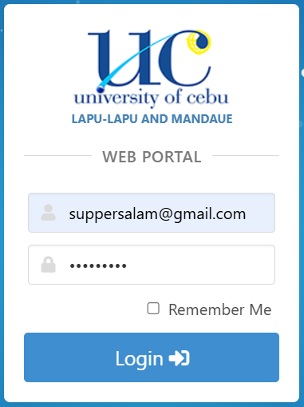
Valid login
Identify Inputs:
username = “suppersalam@gmail.com”
password = “password123”
Expected Output:
System logs the user in successfully.
Actual Output:
“Login successful.”
Comparison:
PASS

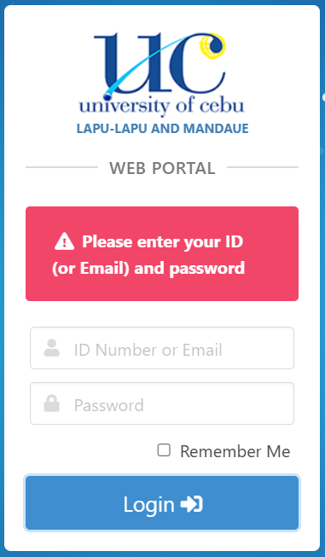
Empty Fields
Identify Inputs:
username = “ ”
password = “ ”

Expected Output:
System shows: “All fields are required.”

Actual Output:
“All fields are required.”

Comparison:
PASS

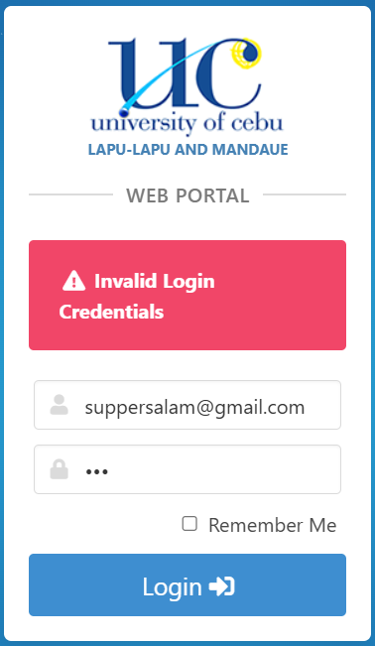
Invalid Password
Identify Inputs:
username: “suppersalam@gmail.com”
password: “123”

Expected Output:
System shows: “Invalid login credentials.”

Actual Output:
“Invalid login credentials.”

Comparison:
PASS

TASK 4 – Identify the Functional Testing Techniques Used
Test Case 1 – Valid Login
Technique: System Testing
Justification:
Checks the complete login functionality as part of the whole system.

Test Case 2 – Invalid Login
Technique: Sanity Testing
Justification:
Sanity testing checks that basic functions work. Verifying error handling for incorrect credentials ensures the basic login functionality behaves correctly.

Test Case 3 – Empty Fields
Technique: Smoke Testing
Justification:
Smoke tests verify that major functions like form validation work. Ensuring the page detects missing fields is a core smoke test.

Test Case 4 – Password Too Short
Selected Technique: Unit Testing
WHY:
Tests a single rule password length which acts like a small, isolated unit.

Test Case 5 – Account Lock After 3 Attempts
Selected Technique: Integration Testing
WHY:
Requires multiple components working together (login + counter + lock system).
TASK 5 – Functional vs Non-Functional Tests
3 Functional Tests for the Login Page
- Verify login accepts valid username and password.
- Verify system displays “Invalid login credentials” for incorrect inputs.
- Verify account is locked after 3 failed attempts.
3 Non-Functional Tests for the Login Page
- Performance Test: Check how fast the login processes under normal load.
- Security Test: Verify password is encrypted and not visible in network requests.
- Usability Test: Check whether error messages are clear and readable for users.

TASK 6 – Benefits & Limitations Analysis
1. How does functional testing improve software quality in the login module?
Functional testing ensures that every requirement of the login page works correctly, such as input validation, error messages, and security rules.It helps identify incorrect system behavior, prevents bugs from reaching real users, ensures smooth user experience, and confirms the login behaves exactly as the specification requires.

2. What limitations may affect the accuracy of your test results?
- Functional testing does not test performance, speed, or server reliability.
- Tests are limited to the scenarios the tester designs untested scenarios may still contain bugs.
- Real world usage might differ from the test environment.
- If mock data or a simulation is used, results may not fully reflect the live system.
- Human error in executing or interpreting test results may produce inconsistencies.

TASK 7 – Practical Execution (Hands-On)

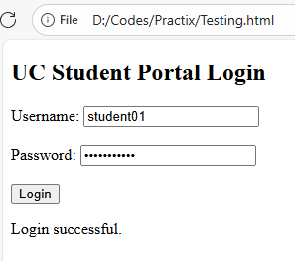
Test Case: Log In Successful
- Enter username: student01
- Enter password: password123
- Click Login
- System shows: “Invalid login credentials.”
- Mark: PASS

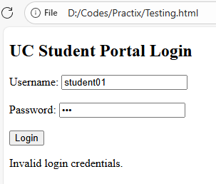
Test Case: Invalid Password
- Enter username: student01
- Enter password: 123
- Click Login
- System shows: “Invalid login credentials.”
- Mark: PASS

